Microorganisms are living organisms which are so small that these are not seen by the unaided human eye. They are less than 0.1 mm in diameter. They are available everywhere even in our body. Microorganisms include bacteria, fungi, archaea, protists and viruses. However, in spite of their small size, they play an important role in regulating our environment by regenerating our atmosphere, maintaining soil fertility, capturing solar energy and by translating it up food chains and so on.

They also have the following actual or possible important industrial applications:

1. In fermentation technology, microorganisms increase the rate of formation of products such as alcohols, vinegar, beverages, antibiotics, enzymes, vitamins, plant growth regulators, amino acids, biogas etc. hence it is very important to understand the relationships between the rate of product formation, the rate of growth of microorganisms and the rate of consumption of nutrients by microorganisms.
2. In mining industry, microorganisms are used to leach undesirable elements from ores.
3. In sanitary engineering, microorganisms are useful in removing pollutants from waste water discharged into the environment.
4. In bioconversion of solar energy, microbes can be used to absorb solar energy on a large scale and then they can be used as fuels.

**Microbial growth in a Chemostat:** A chemostat is a laboratory apparatus used for the continuous culture of microorganisms. It can be used to study competition between different populations of microorganisms.

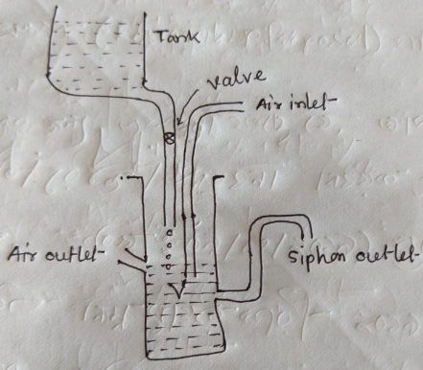

**Figure-01: Chemostat**

Let the chemostat contains a tube of fixed volume  for the medium. This medium contains an excess of all nutrients required by the microorganisms except one nutrient which is called the growth limiting factor since its shortage reduces the growth rate of microorganisms. The microorganism consume this nutrient and, in order to maintain a steady state, the medium is replenished at a steady volume rate  per unit time from a tank, where  is called the dilution rate. At the same time, to keep the volume of the nutrient medium in the chemostat constant, the medium along with the microbes is siphoned off at the same rate .

Let  be the population of microorganisms per unit volume in the medium at time  and let  be the concentration of the rate limiting nutrient in the medium at time . We assume that the growth rate of  is equal to the product of  and a function  of  so that



where  is an increasing function of  and on the basis of experimental evidence , Monod (1949) proposed the law



Due to siphoned outflow of volume  per unit time, a number  of microorganisms flows out per unit time. The equation (1) becomes,





Now, in the time interval , the amount of nutrient in the medium

1. is increased by  due to inflow of nutrient from the tank,  being the constant concentration of nutrient in the tank.
2. is decreased by  due to the siphoned outflow of the nutrient from the tube; and
3. is decreased by  due to the consumption of the nutrient by the microorganisms and  is the constant of proportionality.

From (1), (2) and (3), we obtain



Proceeding to the limit as , we get





The differential equation thus obtained to determine  and are,



If we know the values of  and of  and at , we can solve (5) to get  and  at any time 

Steady states: For steady state, we know  and . If ,  be the steady state solution of (5), then we have

 

From the 1st equation of (6), we obtain

 and 

From the 2nd equation of (6), we obtain

For , it gives 

For  , it gives 

Therefore, there are two steady points  and .

**Stability of steady states for Chemostat:** Consider the chemostat model



The system has the following two steady states:

 ,  

 ,  

The first state (2a) is called the washed-out steady state and the second state (2b), is called the normal steady state.

The first state can arise when  so that  is always negative and , .

Now we consider slight deviations  and  from the steady state, i.e, we write

,  

Substituting (3) in (1) and neglecting higher term of  and , we get



We try the solution,

,  

Substituting (5) in (4), we have



Eliminating A and B, we obtain the equation for determining , i.e,

 

Both the roots are real and both are negative if

 

If (8) is satisfied, then from (5), both  and  approach zero as so that from (3), and . Consequently, the equilibrium position  is stable and is in fact a node. If (8) is not satisfied that is if , one of the values of  is positive and  and  can increase so that the equilibrium position is unstable.

Biologically, the foregoing discussion gives the following: if , and some microorganisms are introduced in the chemostat, they will be ultimately washed out; however, if , the populations of the microorganisms will increase.

Now we will discuss the stability of second steady state. This will give a positive real value of  only if , and then  only if







Thus a necessary and sufficient condition for the existence of the normal steady state position is

 

To discuss the stability of the second state, we consider

,  

Substituting (10), in (1), we get



where 

Neglecting products, squares and higher powers of  and  and using (2b), we obtain



Using (5) in (13), we obtain



Eliminating A and B from 1st and 2nd equations of (14), we get from 1st equation



Putting the value of A in 2nd equation, we get







 

Since , , , , and  are all positive, both the roots of this equation are real and negative or both its roots are complex but with negative real parts. In either case,  and  approach zero,  approaches infinity and the normal steady state is asymptotically stable, in fact, it is a node.

Figure-: Operating diagram for the stability of the two states. BOOK-PAGE 26

**Growth of Microbial Populations:** Let  be the population of microorganism per unit volume in the medium at time  and let  be the concentration of the rate- limiting nutrient in the medium at time . Then the microbial growth in a chemostat is defined as,



where  is a dilution rate and  is specific growth rate function.

If there is no intake of fresh nutrient or there is no siphoning off of the medium and microorganisms, then  and the equation (1) becomes,



These equations give,



From (2) and (3), we get



Integration of (4) gives  as a function of  and then  determines the growth curve of the population. Since , and  is an increasing function of . Since  is an increasing function ,  is a decreasing function of  ; since ,  approaches zero as  approaches . Thus the population size has a limit .

Also





Now 





Hence the growth curve has a point of inflection if



This point of inflection will occur before or after half the final population size is reached according as



Thus each growth curve is, in general, as s-shaped or a sigmoid curve with a point of inflection.

From (3) we get



This shows that the decay curve for  has a point of inflection and occurs at the same time at which the points of inflection of the growth curve for  occurs. At this time,  changes from positive to negative while  changes from negative to positive.

**Question-01:** What is microbial population? Write down the importance of microbial population.

**Question-02:** Discuss the Microbial growth in a Chemostat.

**Question-03:** Explain the stability of steady states of microbial growth in Chemostat.

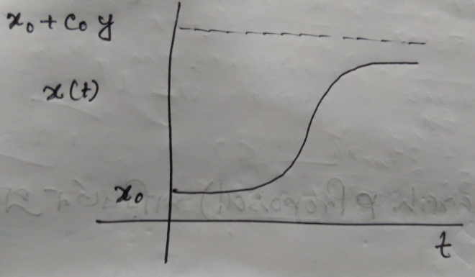

**Figure-01: Growth curve for population size**

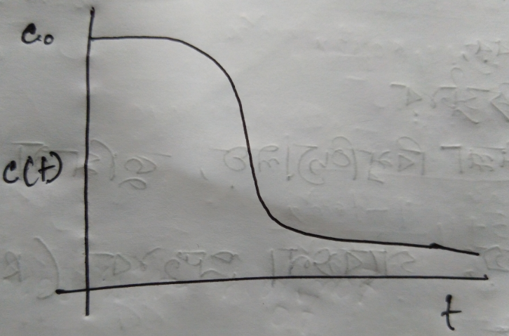

**Figure-02: Decay curve for substrate concentration.**

If  then from (4), we have



This equation is called Pearl-Verhulst equation and the curve obtained is called the logistic curve.